**MTE 203 – Advanced Calculus**

**(Fall 2019)**

**MATLAB Laboratory Worksheet 1[1]**

Student Name

Camille Helena Walters

Student ID

20716280

**Objectives**

1. Get familiar with creating MATLAB function and script files.
2. Learn how to use the MATLAB ‘fsolve’ command to find the roots of the given system of non-linear equations using a given set of initial guesses.

**Solving a System of Non-Linear Equations**

Consider the following system of three non-linear equations:

$$\left\{\begin{aligned}x_{1}^{2}+e^{0.2x_{2}}=x_{2}x_{3} \\ x_{1}x_{2}x_{3}=1 \\ x_{1}+2x_{2}x_{3}=x_{3}^{2} \end{aligned}\right.$$

**Questions:**

1. Write the three above functions as f, g and h in the table below:

$$\left\{\begin{aligned}f\left(x_{1},x_{2},x_{3}\right)= \\ g\left(x_{1},x_{2},x_{3}\right)= \\ h\left(x_{1},x_{2},x_{3}\right)= \end{aligned}\right.$$

Create a Matlab function that defines each one of these functions and save the associated “*.m” file as “TripleFunc_<Lastname>.m”.

1. Write a MATLAB script to find the solution to these non-linear equations. Submit this script with this worksheet as a *.m file saved as “Nonlinear_<Lastname>.m”.
2. Solve the system for the two “first initial guesses” listed in the table below. Write your obtained solutions in the specified fields.

|  |  |  |
| --- | --- | --- |
| First initial guess: $$x_{0}=\left(\begin{matrix}-0.5 & 0.5 & -0.5\end{matrix}\right)$$ | Roots found | Corresponding function values for the roots |
| $x_{1}=$ 0.6338 | $f\left(x_{1},x_{2},x_{3}\right)=$ 2.7767e-12 |
| $x_{2}=$ 0.8105 | $g\left(x_{1},x_{2},x_{3}\right)=$ 8.3125e-12 |
| $x_{3}=$ 1.9466 | $h\left(x_{1},x_{2},x_{3}\right)=$-4.1185e-12 |
| Second initial guess $$x_{0}=\left(\begin{matrix}-0.5 & -0.5 & -0.5\end{matrix}\right)$$ | Roots found | Corresponding function values for the roots |
| $x_{1}=$ 0.7224 | $f\left(x_{1},x_{2},x_{3}\right)=$ 1.9875e-9 |
| $x_{2}=$-0.7409 | $g\left(x_{1},x_{2},x_{3}\right)=$-3.0240e-10 |
| $x_{3}=$-1.8684 | $h\left(x_{1},x_{2},x_{3}\right)=$-4.0122e-10 |

1. Calculate the function values by inputting the values of the first initial guess root values from the table above into the TripleFunc function. Write the respective function values below.
$$\left\{\begin{aligned}f\left(x_{1},x_{2},x_{3}\right)=7.8866×{10}^{-10} \\ g\left(x_{1},x_{2},x_{3}\right)= -1.2059×{10}^{-10} \\ h\left(x_{1},x_{2},x_{3}\right)=-1.2566×{10}^{-11} \end{aligned}\right.$$

2. Compare these function values to the function values determined in Q3.
   1. Are they the same (Yes/No)? **No**
   2. Why or why not? Please explain (maximum 3 sentences).

**They are not the same because these “guesses” (which are the roots that I inputted) are likely to be closer to the real roots. Therefore, the function value is not the same, and the solutions in 4 is more accurate than those in 3.**

1. Plot the functions f(x1,x2,x3), g(x1,x2,x3) and h(x1,x2,x3) on the same axes in 2D and using the same range for variables x1, x2 and x3.

**Note:** All figures should include axes labels, legends (if necessary) and caption.

* 1. Create a script called “PlotFuncLarge_<Lastname>.m” for x values ranging from -10 to +10 with a step size of 2. Insert the resulting figure below (Figure 1).

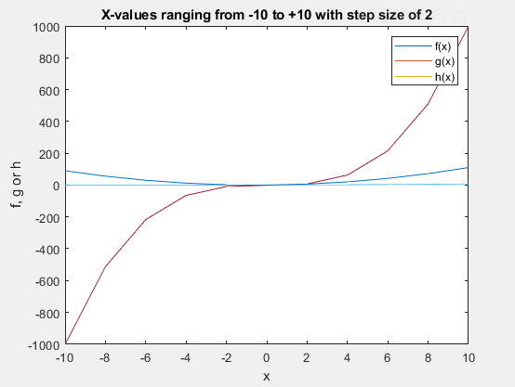

* 1. Create a script called “PlotFuncSmall_<Lastname>.m” for x values ranging from -2 to +2 with a step size of 0.2. Insert the resulting figure below (Figure 2).

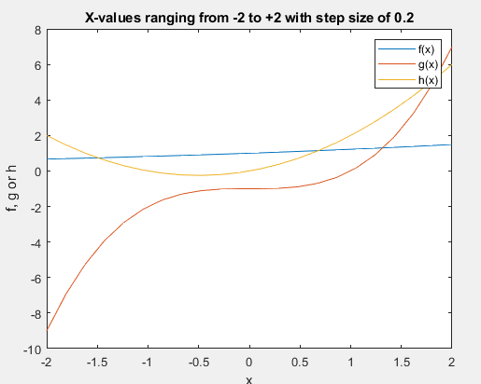

1. Compare the figures obtained in Q6, and answer the following questions:
2. Should the functions intersect each other? Briefly describe what the figures demonstrate. Please explain (1-2 sentences).

**Yes, because we are plotting a system of 3 equations with 3 variables, but are now using only the x values to represent all 3 of these variables. Therefore, they must intersect, since the variables are all used across the full range.**

1. What exactly does MATLAB predict with fsolve? Please explain (1-2 sentences)

Matlab predicts the roots of the linear system of equations.

Once you complete all the required questions, please save this document as MATLAB Worksheet 1_<Lastname>.docx.

**Deliverables to be included in your “zip” file:**

1. TripleFunc_<Lastname>.m
2. Nonlinear_<Lastname>.m
3. PlotFuncLarge_<Lastname>.m
4. PlotFuncSmall_<Lastname>.m
5. MATLAB Worksheet 1 <Lastname>.docx

**Submission:**

To submit the zip file, please use the Lab 1 Dropbox folder in LEARN:

**Course materials/Content/Matlab Laboratories and Projects/Matlab Laboratory 1 – September 12, 2018/Matlab Laboratory 1 – Worksheet Dropbox**

**IMPORTANT:  
Please note that the dropbox will only accept one file per submission. Zipping the files will ensure that we get all your related files for grading. Once you click the submission button any additional files will be treated as a late submission.**

1. Please note that this Laboratory Worksheet must reflect your individual work and that submissions are individual